ol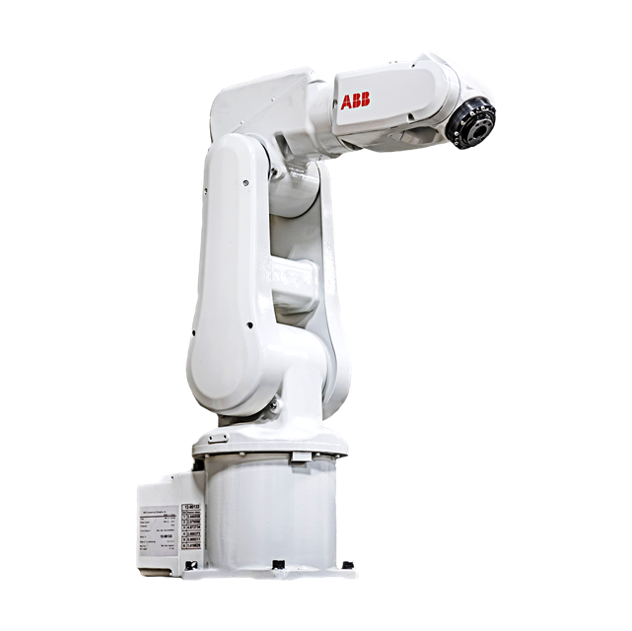

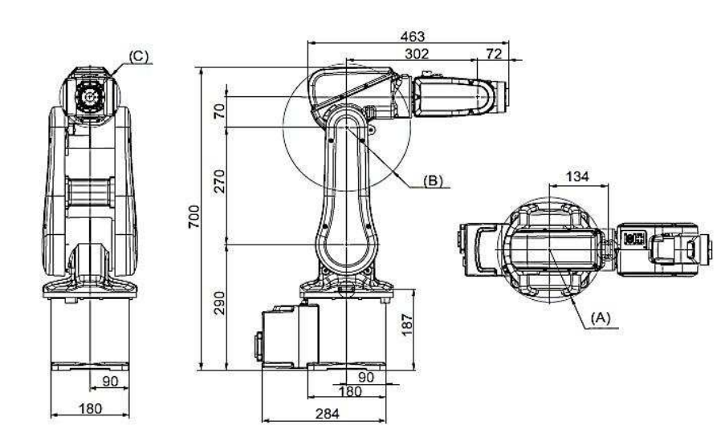



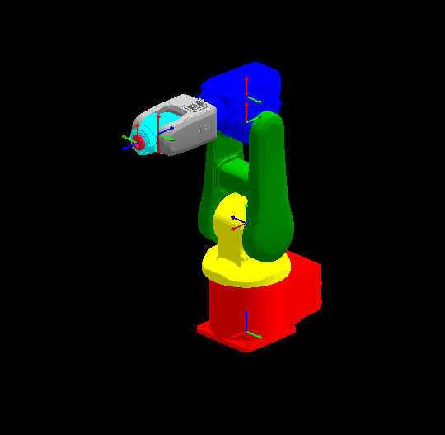

DH table:

|  |  |  |  |  |
| --- | --- | --- | --- | --- |
| Link | θi | di | ai | αi |
| 1 |  |  |  |  |
| 2 |  |  |  |  |
| 3 |  |  |  |  |
| 4 |  |  |  |  |
| 5 |  |  |  |  |
| 6 |  |  |  |  |

https://in.mathworks.com/help/robotics/ref/rigidbodyjoint.html